**Module 7: Portfolio Milestone**

Ana Rios Salgado

Colorado State University Global

MIS548: Capstone - Business Intelligence and Data Analytics

Dr. Steve Chung

July 2, 2023

**Module 7: Portfolio Milestone**

Abstract

This research analyzes specific attributes of European ski resorts from a public dataset. The main goal of this portfolio and research is to share outcomes from the analysis with Vail Resorts on key attributes to prioritize when looking into resort acquisition. Vail Resorts is the selected organization to receive recommendations from this portfolio project due to the writer’s employment with this business. While certain attributes such as the number of chair lifts and prices are known to impact resort success and revenue, this research provides quantitative data as to the effects that resort attributes have on other resort characteristics. The relationships analyzed are between the highest peak and the total number of slopes, as well as the total number of slopes and day pass prices. The research finds that there are positive and significant correlations between higher peaks and total slopes as well as total slopes and day pass prices. This shows that the alternative hypotheses presented in this research are approved. This also shows that Vail Resorts should consider higher peaks in order to allow for more slopes and thus a higher day pass price potential. It is recommended that Vail Resorts continue to analyze relationships between attributes of the European ski resorts captured while also expanding research to include qualitative data on demand and guest interest on specific resort attributes.

# Introduction

Research projects can be very helpful to companies in finding answers to relevant business questions, identifying areas of improvement, and testing different theories regarding operations and objectives (Vogt et al., 2012). For Vail Resorts, research projects are often used to test digital experiences, test different attributes that appeal to target audiences, and to test key resort attributes that affect guest capture. For this portfolio project, a public dataset on European Ski Resorts is used to assess the relationship between key variables of ski resorts. While there are several known attributes that affect resort appeal and attraction for guests, the relationship between those attributes and other resort variables will be measured to assess how valuable certain attributes are for resort acquisition.

Objectives

Vail Resorts serves as a mountain resorts organization. It owns and operates 37 ski resorts in the United States including nearby lodging and merchandise locations. It has slowly been expanding ownership across Europe and Asia through the acquisition of existing resorts previously owned by independent companies. Once a resort is acquired by the company, the resort adopts Vail Resorts branding, services, and team structure of support. This consists of both on-resort staff that lead day to day operations as well as corporate staff that assist on the higher-level insights and analysis. This type of structure is common among this industry and particularly for Vail Resorts. It often results in increased efficiency for individual ski resorts than when independently owned and operated (Falk, 2009). This is due to the close collaboration among corporate and operations teams in implementing changes based on analytical and financial insights as well as from observations in day-to-day efficiencies. This ability to implement business solutions based on database insights and analytics ensures that the organization is leveraging business intelligence to guide daily operations (Nelson, 2015).

One of the goals for Vail Resorts is to continue to expand service opportunities while granting guests the “experience of a lifetime”. This includes the introduction of the sport to new target audiences and to new locations. Therefore, it is important for Vail Resorts to continue to expand and acquire resorts that may fit within the brand and service menu of the organization. The dataset used for this critical thinking assignment includes third party data on European resorts (Kaggle, 2020). This data will be used to answer business questions regarding variables that should be considered for resort acquisition.

Overview of the Study

The selected dataset for analysis includes 18 different variables with 376 rows of data. From the columns, there are 14 variables that are numeric, three that are strings, and one that is Boolean. The types of variables include the country, the highest peak, the number of chairlifts, the price of the day pass, whether night skiing is available, lift capacity, peaks per skill level, etc. From this dataset, the variables that are considered to have the highest impact on sales and guest visitation will be selected for correlation and regression analysis. The selected attributes for analysis are peak height and number of slopes since these are thought to affect several aspects of resort operations such as day prices, difficulty of lessons, opening days, etc. If the attributes selected show a positive correlation results when tested, this means that they should be some of the first attributes to be considered when assessing resorts for acquisition.

Research Questions & Hypotheses

To identify trends within the variables of the dataset, hypotheses will be developed for the organization. The hypotheses will be used to provide direction as to the attributes tested and what the expected outcome should be (Travers et al. 2017). It will be important to consider different visuals to showcase findings and to highlight the main takeaways from the analysis.

The first business question that Vail Resorts hopes to answer through the dataset is the following: Is there a relationship between higher peaks and total slopes available for guests? The following hypothesis will be used to address this question:

* H0: There is not a relationship between peak altitude and number of total slopes
* H1: There is a relationship between peak altitude and number of total slopes

Through the analysis of the relationship between peak altitude and total slopes, Vail Resorts can determine whether they should consider a higher peak in their acquisition in order to allow for a higher number of slopes for guests. While this is thought to be the case, this has not been tested through a research approach with data to support this perspective. This is especially important when there might be other factors that determine the total number of slopes beyond the peak altitude. Therefore, the total slopes will be the independent variable, and its relationships with other attributes in the dataset will be assessed.

The second business question that Vail Resorts will aim to answer through the analysis of the dataset on European Ski resorts is whether the number of total slopes should have an impact on day pass prices. The hypothesis used to answer this question are the following:

* H0: There is not a relationship between number of total slopes and day pass prices
* H1: There is a relationship between the number of total slopes and day pass prices

For this business question, day pass prices will be the independent variable whose relationship will be tested against total slopes and the other variables in the dataset.

Literature Review

This critical thinking assignment consists of a literature review of four scholarly sources that surround the theme of this course’s portfolio project. The first resource reviewed is from Martin Falk in which he explores whether multi-resort ski conglomerates are more efficient than independent ski resorts (Falk, 2009). Given one of the main business questions from the course’s portfolio surrounds ski resort acquisition by a large conglomerate, this source helps consider what the next steps might be for the selected resort post-acquisition. This source provides insights as to the organizational structure of large business organizations in this industry and how business decisions are made across resorts. The last important component derived from this source is how data analytics is used to guide business decisions within ski resorts.

The second source is a MarketLine company profile on Vail Resorts (MarketLine, 2023). From having this be the selected organization for the portfolio project, it is important to consider the latest data available on this business. From the source, it was discovered that Vail Resorts has received numerous recognitions for the acquisitions of its resorts. This is very relevant data for the sake of the research questions in the portfolio since it shows that Vail Resorts has successfully analyzed the attributes that make an independent resort a good fit for acquisition. This also gives us insights as to similarities among acquired resorts that made them a good fit for the company to take over. This source shares the top competitors for Vail Resorts to be Hilton Worldwide Holdings, Hyatt Hotels Corp, and Marriott International Incorporation. Lastly, this source goes to describe Vail Resorts to be a luxury and destination-based travel company that operates mountain resorts.

The third source reviewed in this literature review is a book from Nelson on *Business intelligence, strategies and ethics* (Nelson, 2015). This book covers the ethics in the use of data, which is one of the areas also discussed and reviewed for the portfolio project. The book considers the different use cases for data and how to ensure confidentiality and ethical practices with analytical practices. More importantly, it discusses how business intelligence derives from how organizations leverage analytics and their data. Unless an organization is making informed business decisions based on acquired information, it cannot truly leverage business intelligence to improve business based on data. Given the portfolio project is meant to analyze data to answer business questions, it is crucial to consider why that is relevant and how that should be used to drive business decisions for Vail Resorts.

The last source referenced in this literature review is *Motives for Choosing a Ski Destination According to the British Ski Experts Opinion* (Undzhieva, 2022)*.* This source allows us to explore a visitor’s point of view when it comes to visiting specific resorts. At the end of the day, regardless of the attributes of specific resorts for an organization, the guest will be the main driver for profit and sales. Therefore, it is important to also consider the types of guests that are going to each resort and the main drivers that lead guests to want to visit. In this source, some of the main attributes mentioned include length of ski slopes, difficulty of ski slopes, and quantity of lifts. Other hospitality attributes such as lodging options are also mentioned as ones considered by guests.

Methodology

Research methodology is meant to address the “who, what, and how” of a research study. In this instance, the dataset is available through Kaggle as open-source, public data. However, Vail Resorts could also collect similar information through competitive analysis. This is often completed to assess pass prices, lesson availability, and competitive differences among competitors. The type of data that has been collected is quantitative data that reports different numeric variables. The data is numeric because it is outlining attributes that can be counted and measured for the resorts.

The primary software that is used to present visuals and assess the relationship among variables is SAS On Demand. SAS On Demand serves as a data analysis tool and statistical package (Cody, 2018). This tool is selected due to the simple user interface which is easy to understand as well as the strong visual capabilities to summarize data. This tool will be used to analyze summary statistics and produce visuals that could demonstrate key data trends or findings. From there, Tableau will be considered as a secondary tool for further analysis and to visually show summaries of the dataset. This tool is considered because it is a key tool used within Vail Resorts' analytics teams. Both SAS On Demand and Tableau are open source software that should be highly considered for adoption by organizations conducting a high amount of data analysis. This means that the use of this type of tool would not result in any cost to the organization. This can be said about the public version of Tableau but may lead to an organizational cost depending on the type of Tableau license used within Vail Resorts.

Methods

SAS On Demand will be used to conduct a correlation analysis to assess the relationship between the variables “Highest Peak” and “Total Slopes”. This statistical test was selected since it measures the linear relationship between two variables. The visualization of the correlation analysis will be a scatterplot if the variables have an identified relationship. If the variables do have a relationship, then the alternative hypothesis would be accepted. However, if the variables were not proven to have a relationship and the alternative hypotheses were rejected, this would still be meaningful data for Vail Resorts. This is because this would still provide insights as to the two variables of the European resorts. This can also narrow future business questions on key attributes of resorts that may have an impact on one another.

A correlation analysis through SAS On Demand will also be used to assess the relationship between “Total Slopes” and “Day Pass Prices”. If a significant correlation is found, then the alternative hypothesis will be approved showing that a higher number of total slopes should result in a higher day pass price for Vail Resorts. Therefore, it will be important for the resorts considered for acquisition to have a high amount of slopes in order for there to be a higher profit for Vail Resorts via day pass prices. If a relationship is found, then the p-value will be referenced to assess significance. If the correlation is significant, then the second alternative hypothesis would be accepted.

Limitations

The main limitations from this study and data are the numerous factors that could affect whether a resort acquisition is successful. While this study outlines some important attributes to consider that might lead to higher success, there are many other factors that could affect market adoption of a new resort. This is why multiple regression analysis will be important and a secondary step to correlation analysis. The resort dataset cannot anticipate employee turnover after acquisition, decreases in the target audience, unexpected world emergencies (ex. COVID-19 outbreak), etc. Qualitative data might also be helpful for this study to assess overall performance and perception of a specific resort by target audiences. Qualitative data might help determine demand, which would have an impact in day pass prices regardless of the total number of slopes or highest peaks. The other limitation to this study is that the variables that are perceived to have the highest impact on success were selected for further analysis when these might vary based on region. To address these limitations, Vail Resorts should consider further analysis on all variables available and to group them based on location, target audiences, etc.

Ethical Considerations

This dataset was selected due to the public access for further analysis. Originally, a private dataset from Vail Resorts was selected for this portfolio project. However, it was discovered that certain attributes included should be confidential and only visible to internal members of Vail Resorts. While no specific personal data was included, the previously selected dataset included private information about how Vail Resorts prices lessons, lift tickets, etc. Therefore, a public dataset was selected with information that is relevant to the organization without any risk of releasing private data. This reflects an important step in data security and ethical use of data. Through training and dataset protection, it was discovered which datasets should be kept private and which data could be explored in a public forum. Therefore, it is crucial for organizations to consider this same level of security when it comes to internal data that employees have access to. The dataset selected has no risk in further exploration.

Findings

The first step was to conduct descriptive statistics to ensure that there would be no missing values in each of the variables in the analysis. It was confirmed through summary statistics that there were no null values from the dataset on European Ski Resorts. From there, a correlation analysis was performed between peak altitudes and total slopes as seen from Figure 1 below.

**Figure 1**

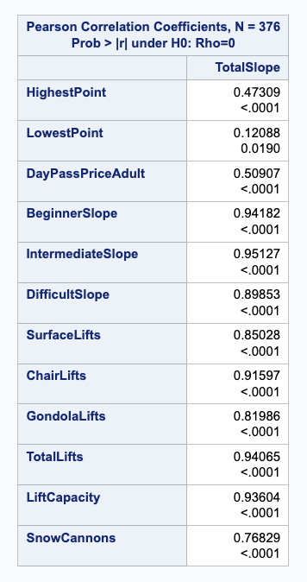*Correlation between total slopes and dataset continuous variables*

*Note*. Screenshot taken on July 1, 2023.

Figure 1 shows the relationship between total slopes and highest peak (also referred to as peak altitude). As stated in the research questions and hypothesis, total slopes is the independent variable and it is being correlated with all continuous attributes in the dataset in case there are meaningful relationships identified for further exploration. The output shown in Figure 1 can also help address the relationship between total slopes and day pass prices.

It can be seen through the first figure that there is a 0.47309 Pearson Correlation between the two variables. This means that the relationship is positive between total slopes and peak altitude. In this case, the higher the amount of slopes, the taller the highest point is. It is then important to analyze the p-value of 0.0001. The p-value is the probability that there would be a correlation between the two variables that is as large or larger than the one obtained by chance alone (Cody, 2021). Given the p-value is lower than 0.05, the correlation is noted to be significant. With that, for our first business question and hypothesis on whether there is a relationship between the total slopes and peak altitude, the alternative hypothesis is accepted.

Looking at Figure 1, there is a Pearson Correlation of 0.50907 between total slopes and day pass prices. The correlation between these two variables also has a p-value of 0.0001, which shows that this correlation is significant. This means that the alternative hypothesis is accepted and shows that there is a relationship between the total slopes and day pass prices. This also shows that the higher the number of slopes at a resort, the higher the day pass price will be. This will be important information for Vail Resorts to consider when it comes to the acquisition of new resorts. It will be important to consider resorts with high peaks since these would result in more slopes and therefore higher day pass prices for guests.

**Figure 2**

*Correlation between total slopes and continuous variables in the dataset*

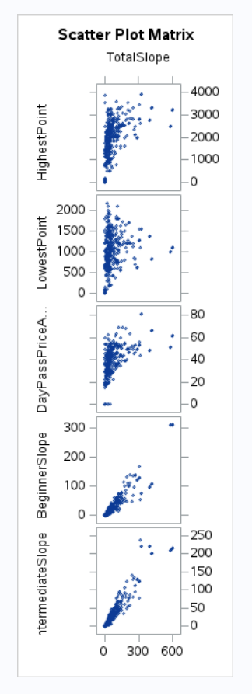

*Note*. Screenshot taken on July 1, 2023.

From Figure 2, the scatterplots from the correlation analysis can be seen. The first scatterplot shows the increase in total slopes based on the increase in highest point. This visual aligns with the analysis from Figure 1 in which a positive and significant correlation is identified. The third scatter plot then shows the positive correlation between day pass prices and total number of slopes. It can be seen that as total slopes increase, the day pass prices increase. This visual shows that there is significant elasticity between slope number and price.

**Figure 3**

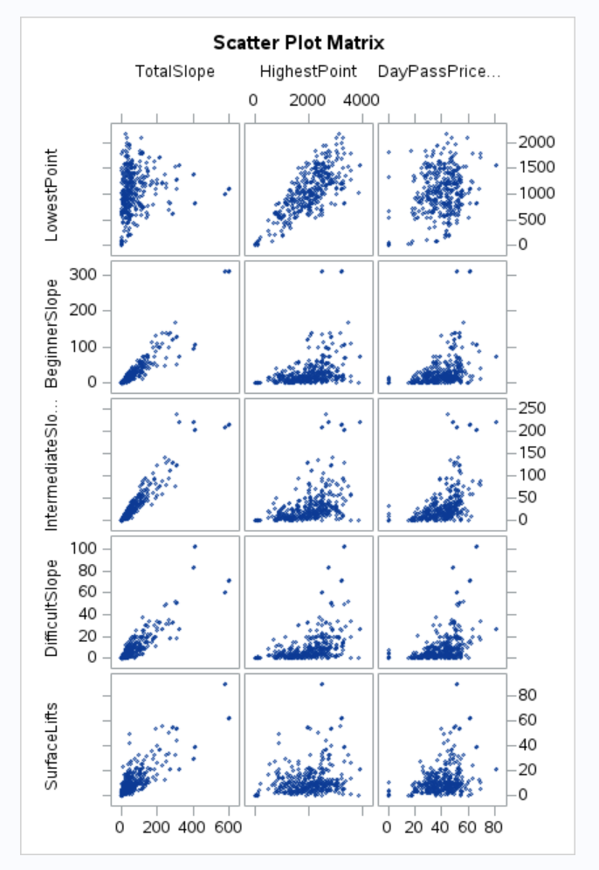*Multiple Regression Output Scatterplots*

*Note*. Screenshot taken on July 1, 2023.

In Figure 3, the scatter plot visuals are taken one step further in multiple regression analysis using total slopes, highest point, and day pass prices as the independent variables. The visuals show positive correlations between highest point (also referred to as peak altitude) and the slope difficulty rating and the number of lifts. There was a much lower visual correlation seen between lowest point and day pass prices.

**Conclusion**

From the analysis completed in SAS Studio, it can be concluded that the alternative hypotheses were accepted for both business questions. This means that there were significant correlations and relationships identified between total slopes and the peak altitude as well as total slopes and day pass prices. For Vail Resorts to choose the resort that might yield the most profit, it might be important to have the highest day pass price as possible. For this to be the case, based on the hypothesis testing, Vail Resorts should consider locations with higher peaks since these would result in more total slopes. The data also shows that the higher number of slopes, the higher the day pass price potential can be.

**Recommendation**

It is recommended that Vail Resorts conduct qualitative research on the attributes that matter most to its target audiences. While the data and results from this analysis show that higher peak altitudes result in higher number of slopes and therefore higher day pass price opportunities, this might not mean that target audiences would be responsive to this. Based on resort location and other attributes in this industry, choosing the resort with the highest day pass price potential might not mean highest revenue opportunity. It is also recommended that Vail Resorts explore other relationships in the dataset and the impact those might have on operations. For example, it can be seen from Figure 3 that day pass prices do vary based on the number of slopes at a specific ability level. It would be important to not only assess whether day pass is the driving motivator for visiting a resort or if the other variables in the dataset should be independent variables for further analysis. With the data analyzed in this portfolio, Vail Resorts should at least consider resorts with high peaks and therefore a high number of total slopes and higher day pass prices.

# 

# References

Cody, R. (2018). *An introduction to SAS university edition*. SAS Institute.

Cody, R. (2021). *A Gentle Introduction to Statistics Using SAS Studio in the Cloud*. SAS Institute.

*European Ski Resorts*. (2022, February 20). Kaggle. <https://www.kaggle.com/datasets/thomasnibb/european-ski-resorts?resource=download>

Falk, M. (2009). Are multi-resort ski conglomerates more efficient? Managerial and Decision Economics, 30(8), 529–538. https://doi.org/10.1002/mde.1470

MarketLine Company Profile: Vail Resorts Inc. (2023). In Vail Resorts, Inc. MarketLine Company Profile (pp. 1–37).

Nelson, K. (2015). Business intelligence, strategies and ethics. Hauppauge, New York: Nova Science Publishers, Inc.

O’Leary, Z. (2021). The Essential Guide to doing your research project. SAGE.

Travers, J.C., Cook, B.G., & Cook, L. (2017). Null Hypothesis Significance Testing and p Values. Learning Disabilities Research & Practice, 32(4), 208-215. <https://doi.org/10.1111/ldrp.12147>

Vogt, W. P., Gardner, D. C., & Haeffele, L. M. (2012). *When to use what research design*. Guilford Press.

Undzhieva, M. (2022). Motives for Choosing a Ski Destination According to the British Ski Experts Opinion. Izesstia, Journal of the Union of Scientists - Varna, Economic Sciences Series, 11(3), 98–106.